**LAB 1: Using INetSim on Kali Linux**

**Course Name**: Malware Analysis and Reverse Engineering (IAM302)

**Student Name**: Nguyễn Trần Vinh – SE160258

**Instructor Name**: Mai Hoàng Đỉnh

**Lab Due Date**: 7/1/2023

**Purpose**

We will use Kali Linux to simulate the Intenet, and the Windows machine will be fooled by it.

**Getting the Virtual Machine 7-Zip Archive Files**

The two files you need are:

* Kali Linux 32 bit VM PAE: Kali-Linux-2016.2-vm-i686.7z (or a later version)
* Windows 2008 Server: Win2008-Target.7z

**Setting the Kali Linux VM to NAT Networking**

* dhclient
* ifconfig

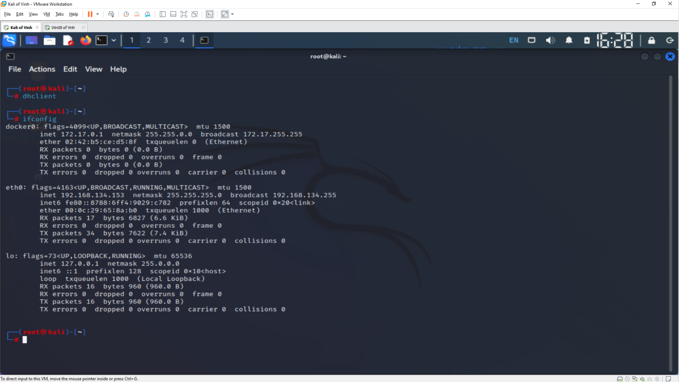

**Checking for a Web server**

* lsof -i :80

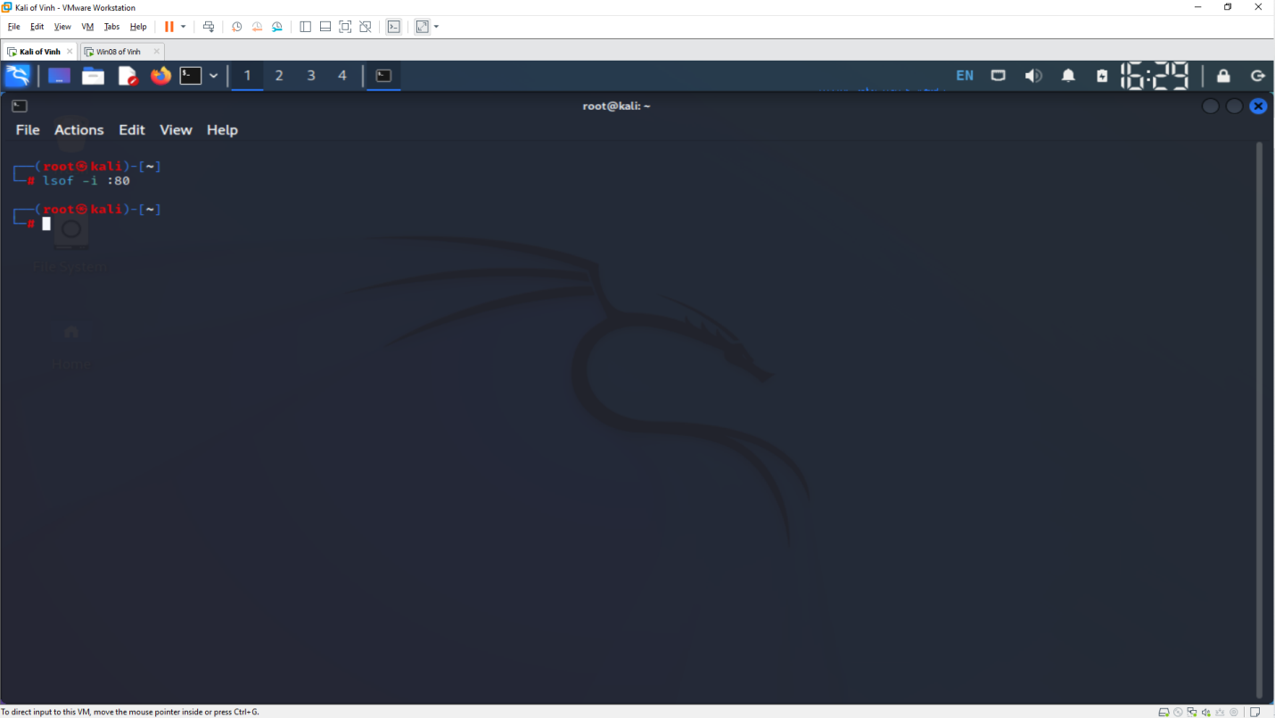

**Configuring inetsim**

* dns_default_ip
* service_bind_address

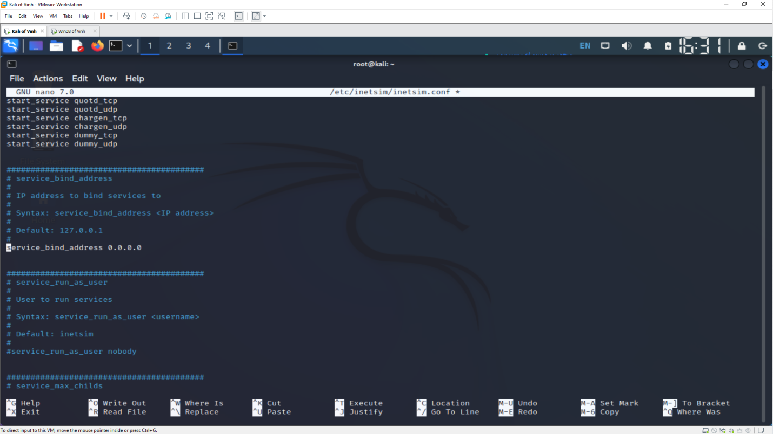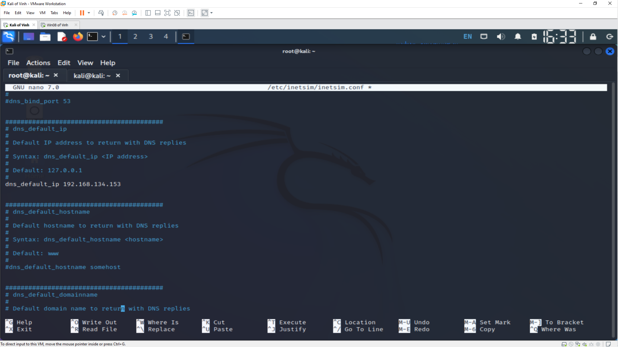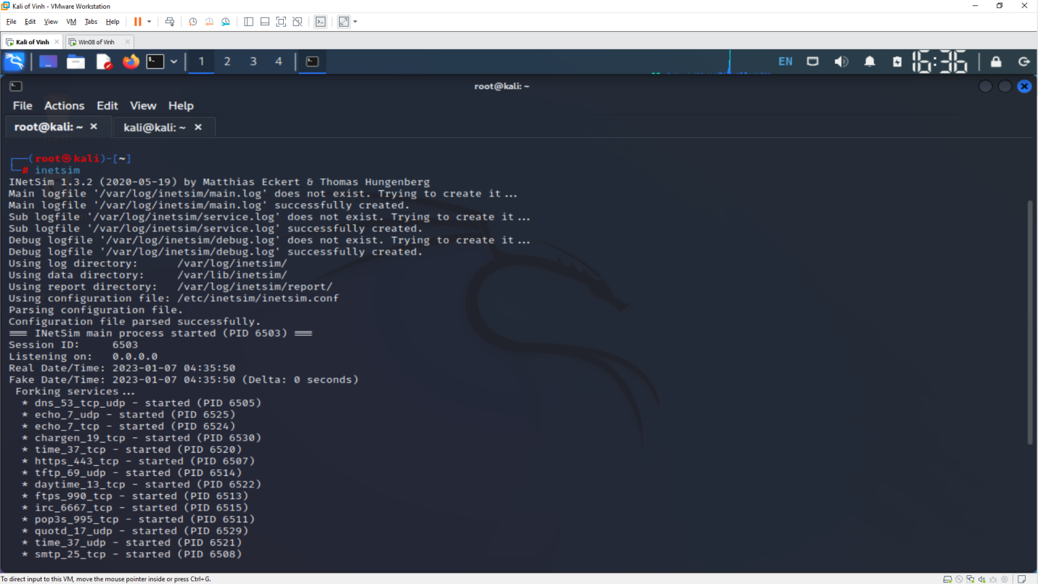

**Setting the DNS Server**

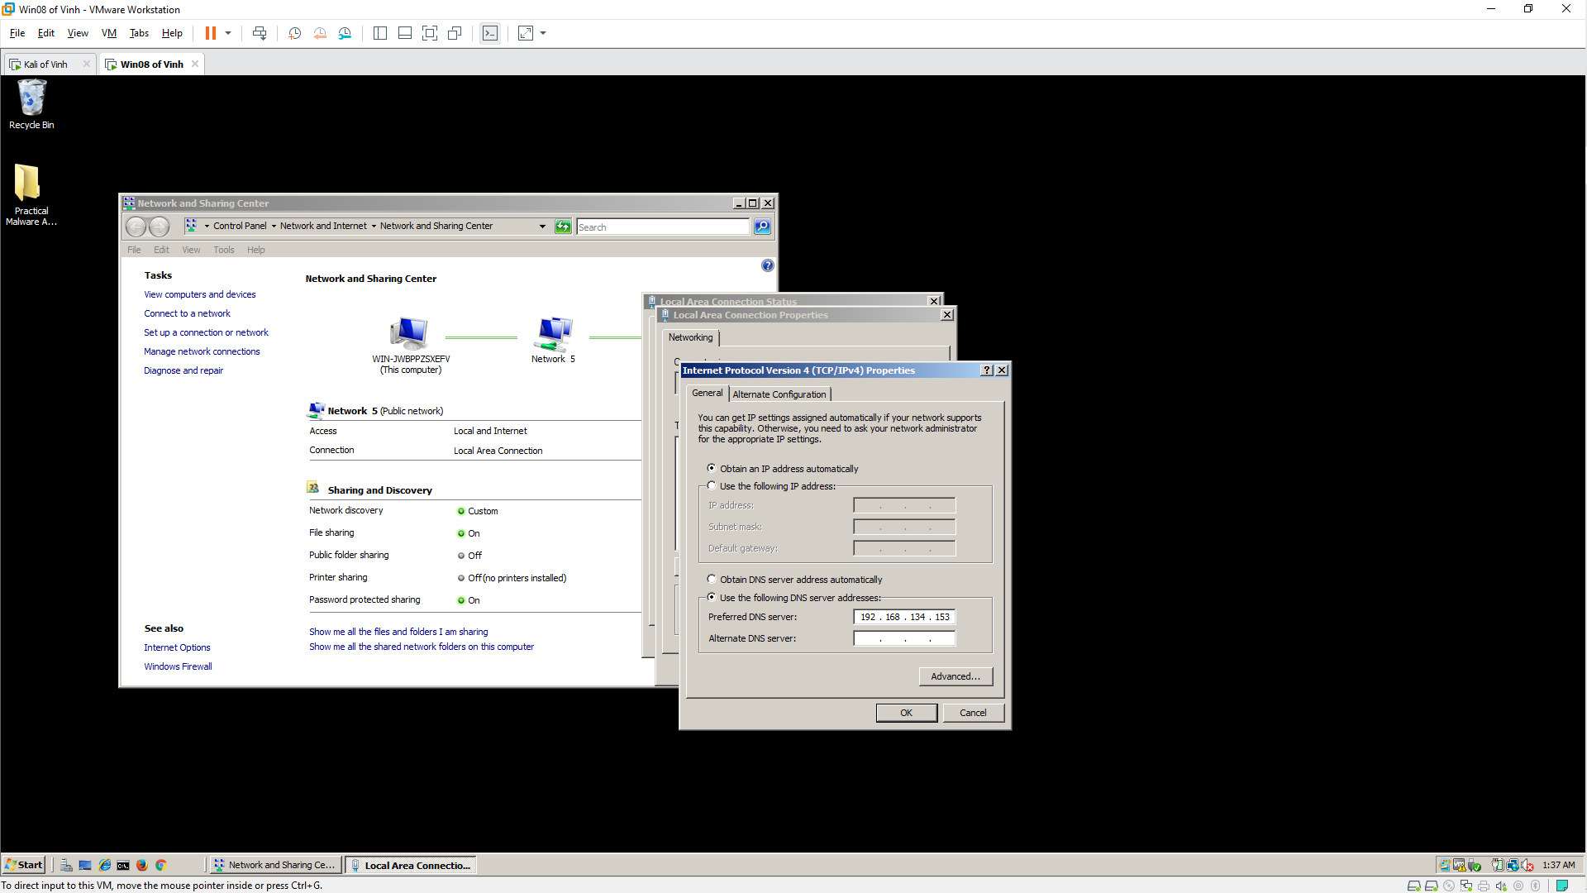

**Viewing an HTTP Web Page** 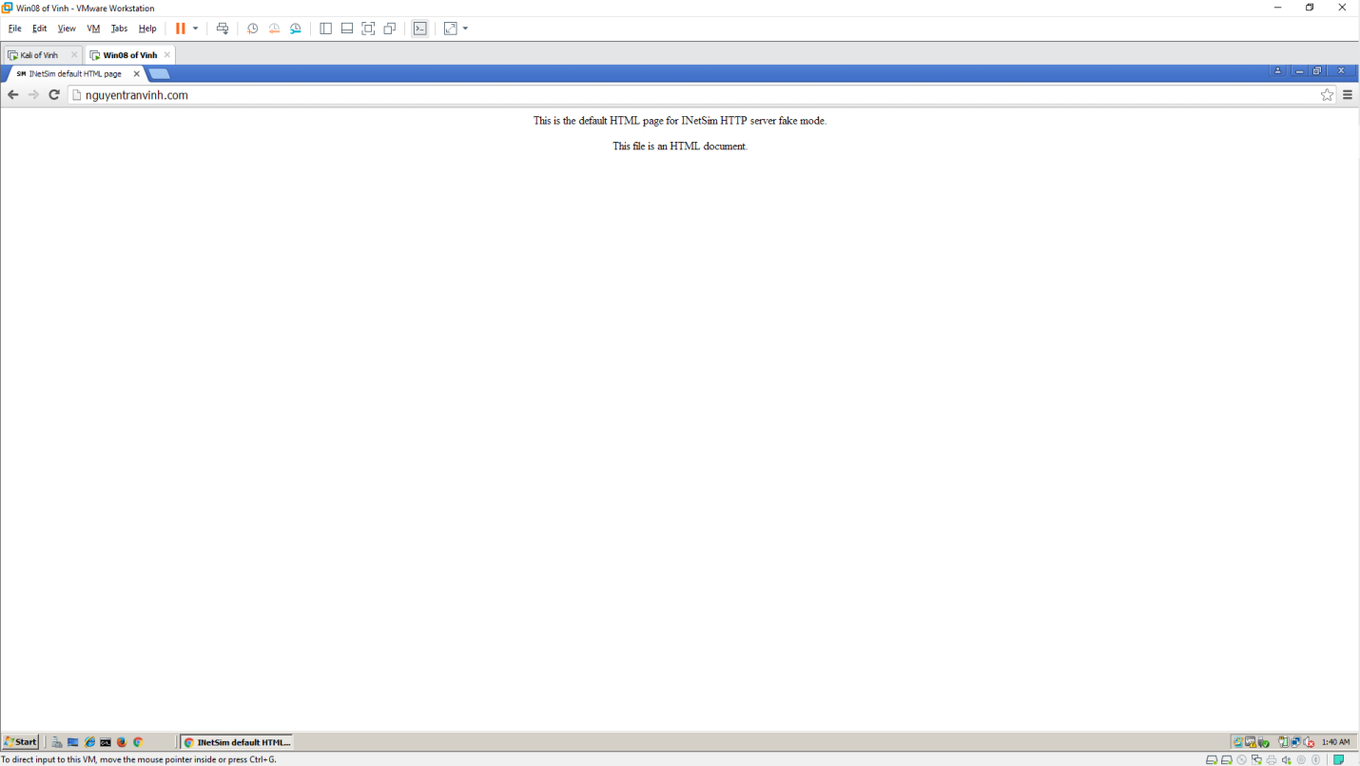

**Scanning**

